Advanced Computer Networks – PCS223
Assignment 5
Name – Writick Parui
Subgroup – CS4
Roll No. – 8025320111
Q.1 Objective: Configure Static Route in Cisco packet tracer
• Static route tells the device exactly where to send traffic, no matter what.
• Static route is often used when your network has only a few routers or there is only one
route from a source to a destination.

Scenario
• Suppose that your company has 2 branches located in Tehran and Shiraz.
• As the administrator of the network, you are tasked to connect them so that employees in the two LANs can communicate with each other.
• After careful consideration you decided to connect them via static route.
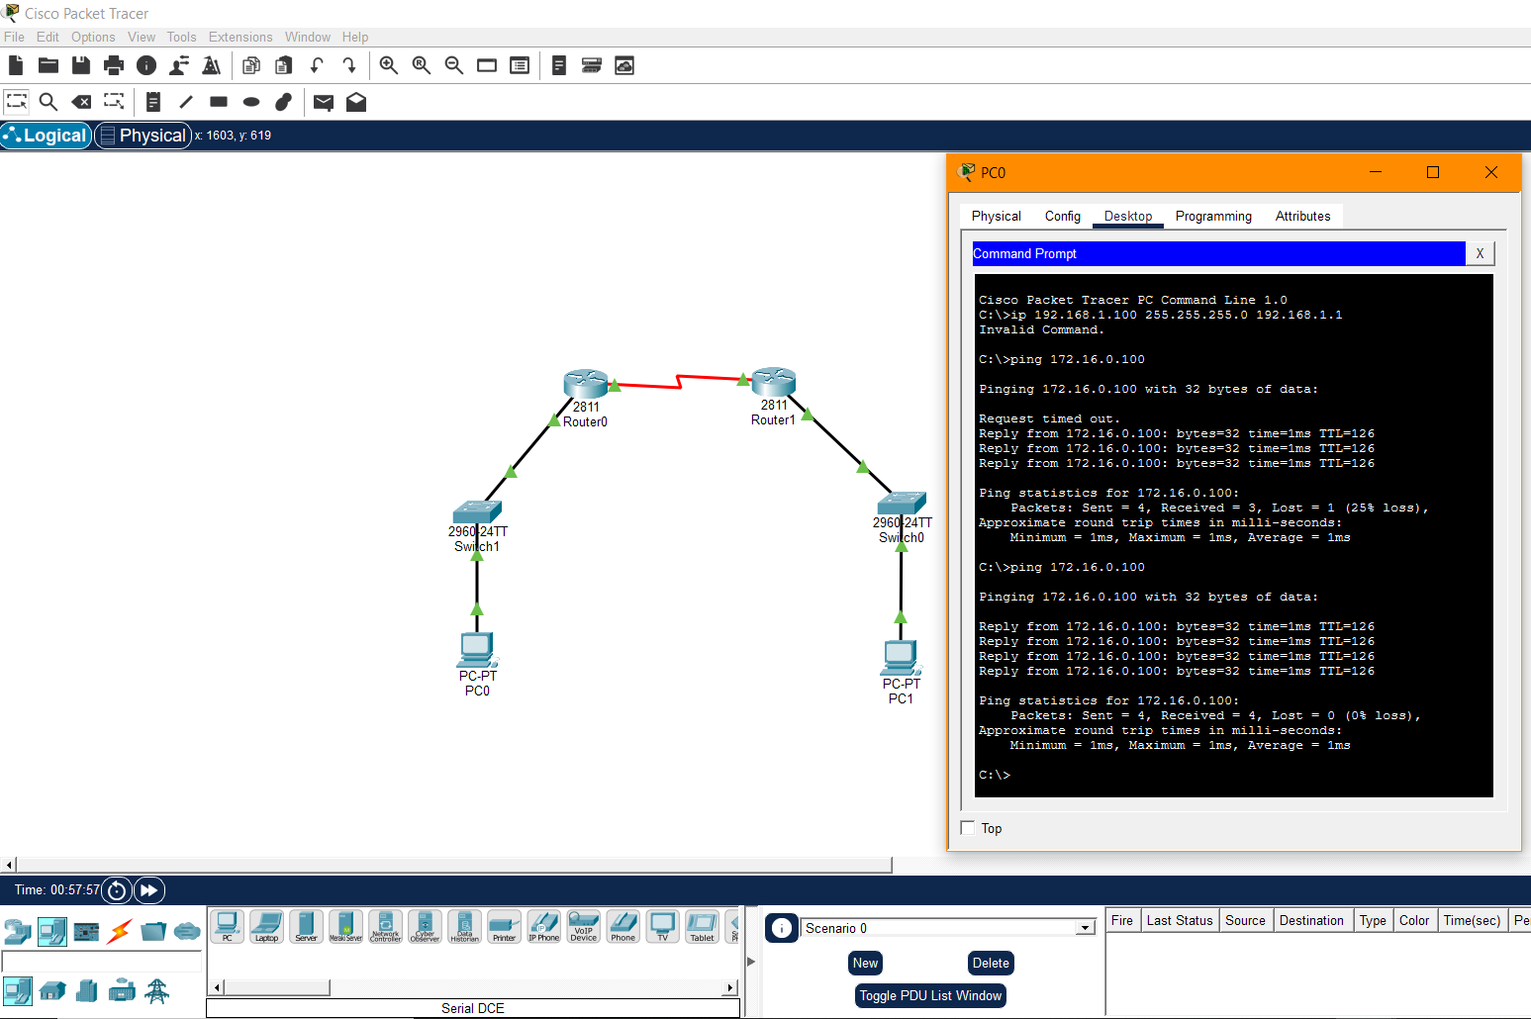
Q.2 Suppose you want to create 3 subnets of a network having network address 198.168.1.0. In another network with network address 220.168.2.0, you want to create 2 subnets. For this scenario configure the end devices and routers accordingly. Connect two different networks (both are subnetted) through static routing and show the message transmission among hosts of the two networks.

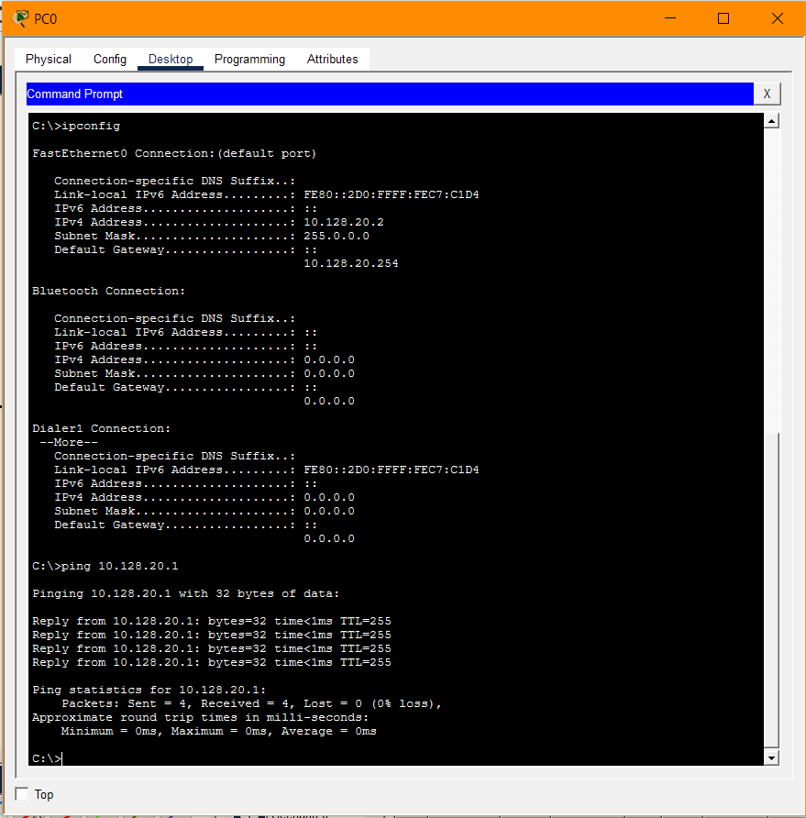
- Create a network of 2 PCs as below.
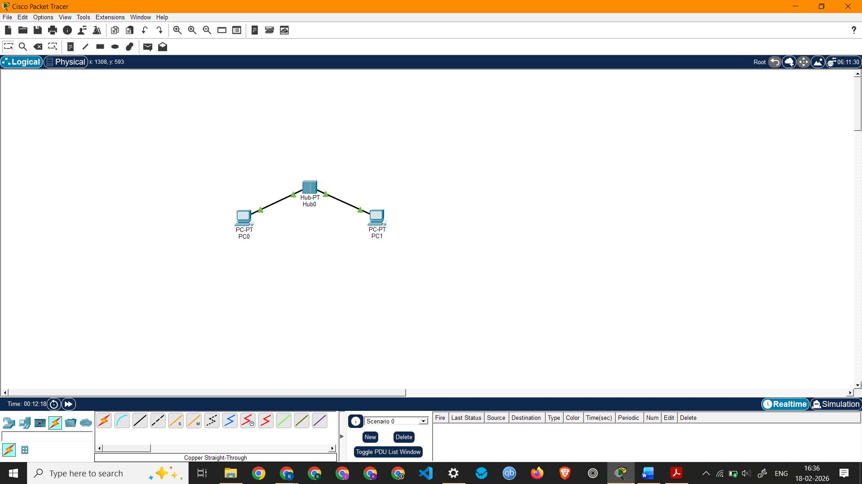

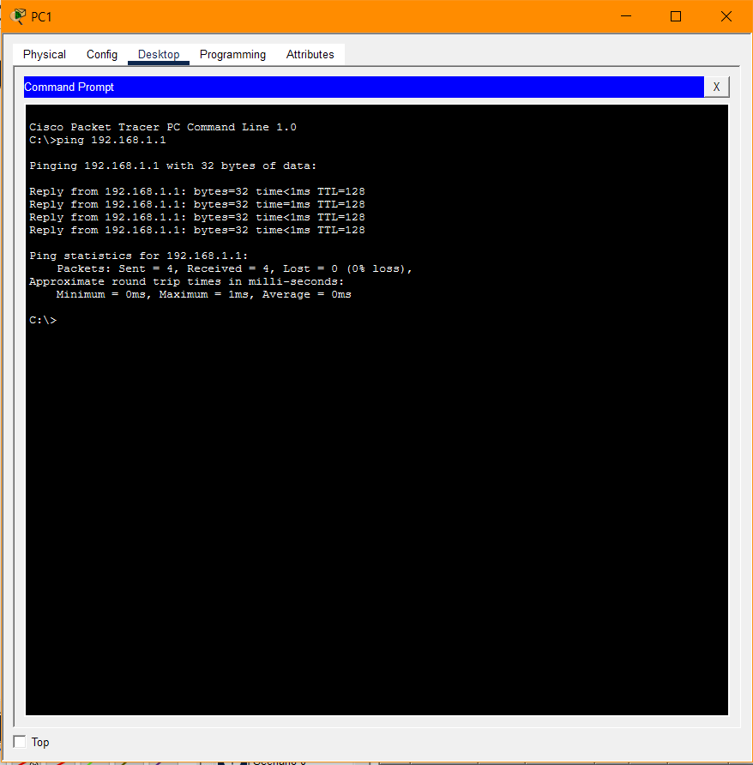

- Connect 2 PCs with a Switch below.
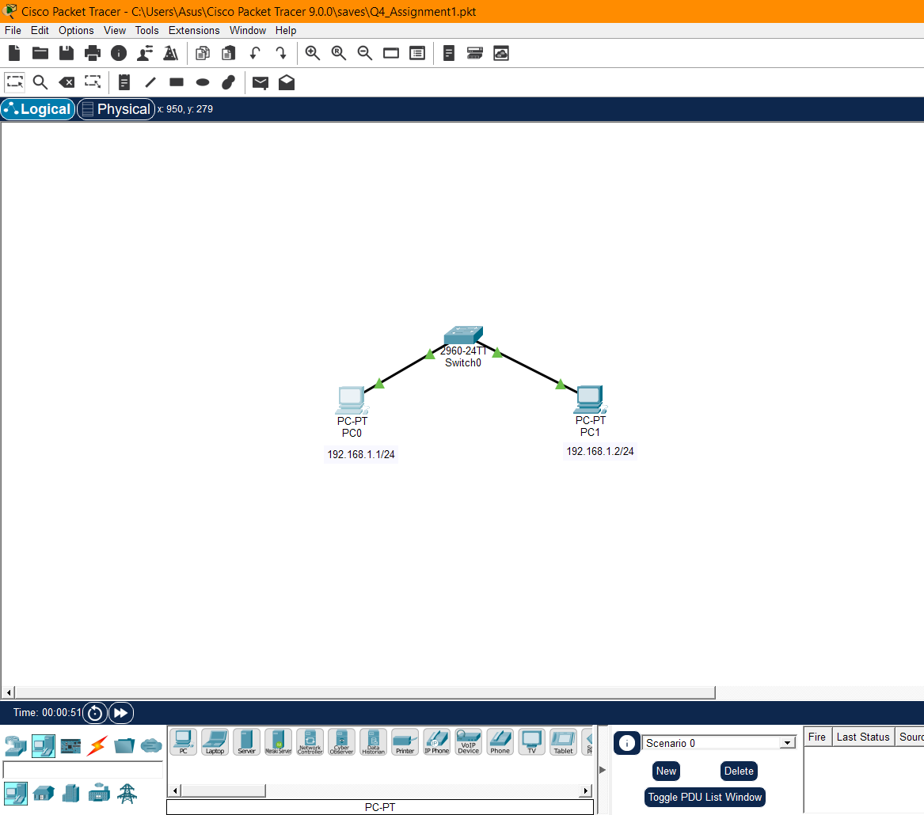
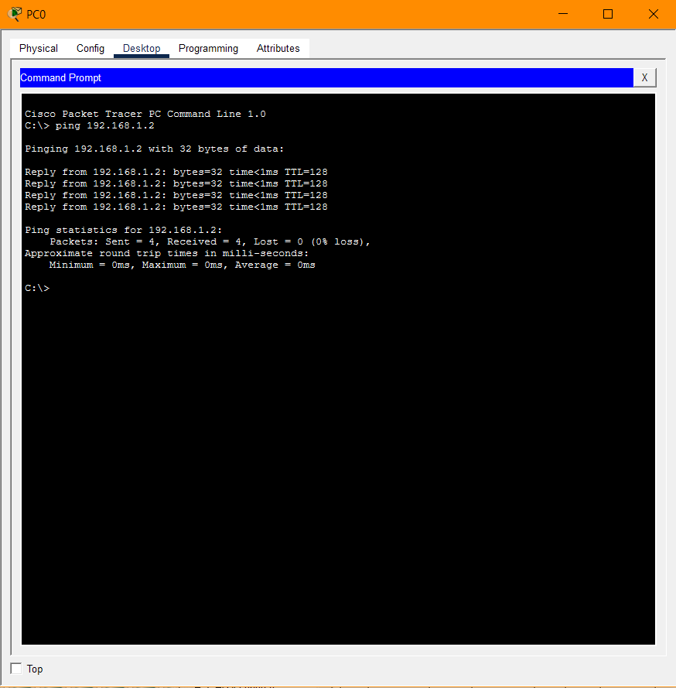
- Create BUS topologies as below.
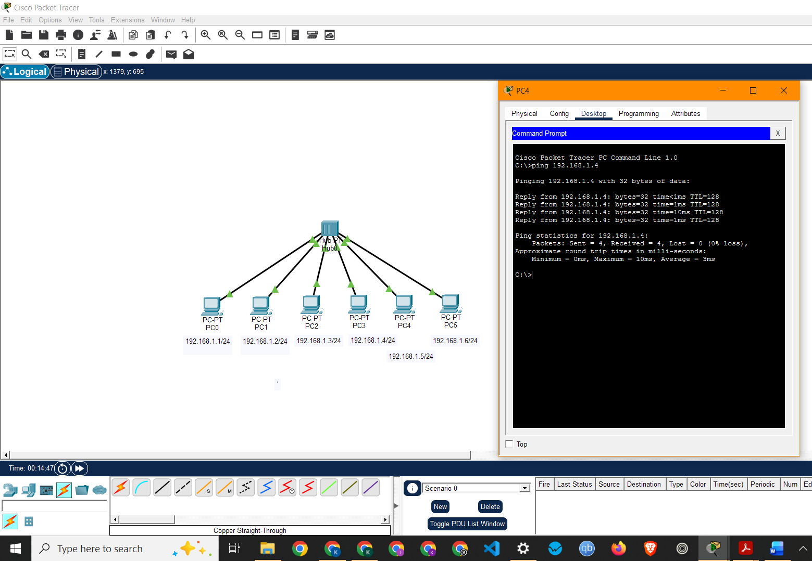
(a)

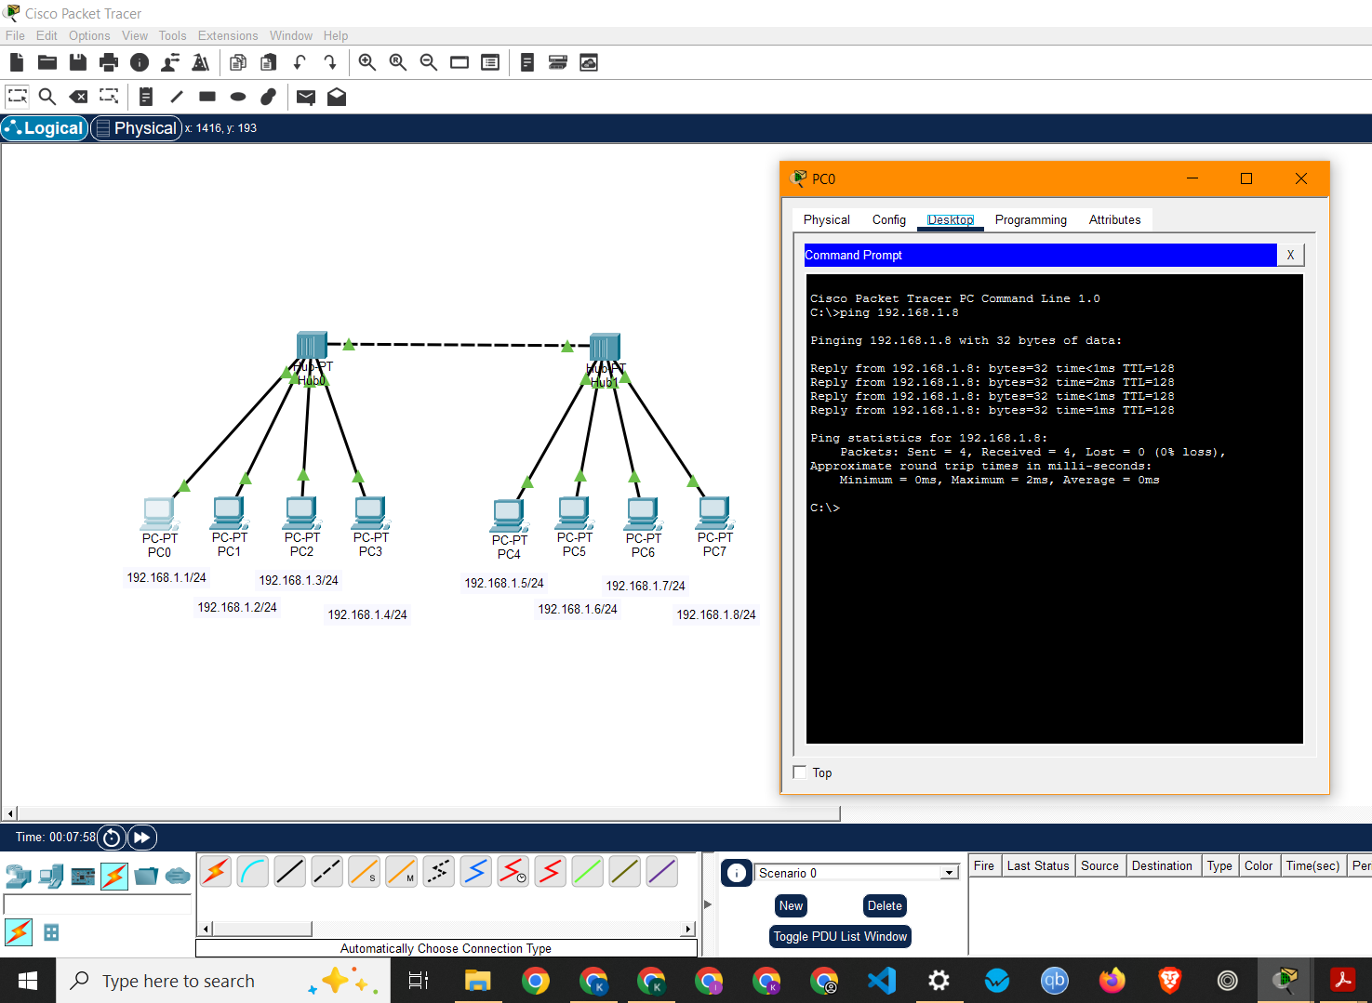
(b)

- Create the following ring topology
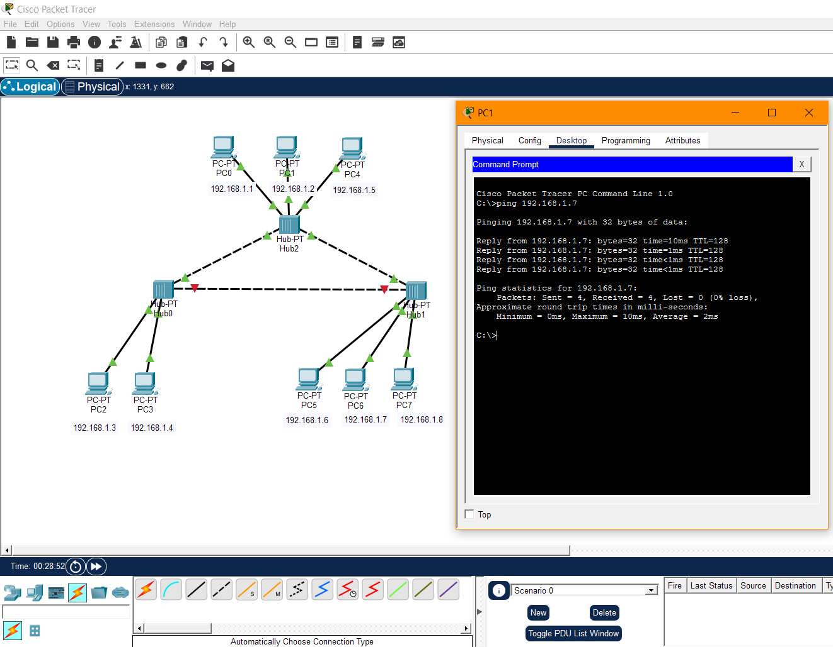

- Create the following ring topology

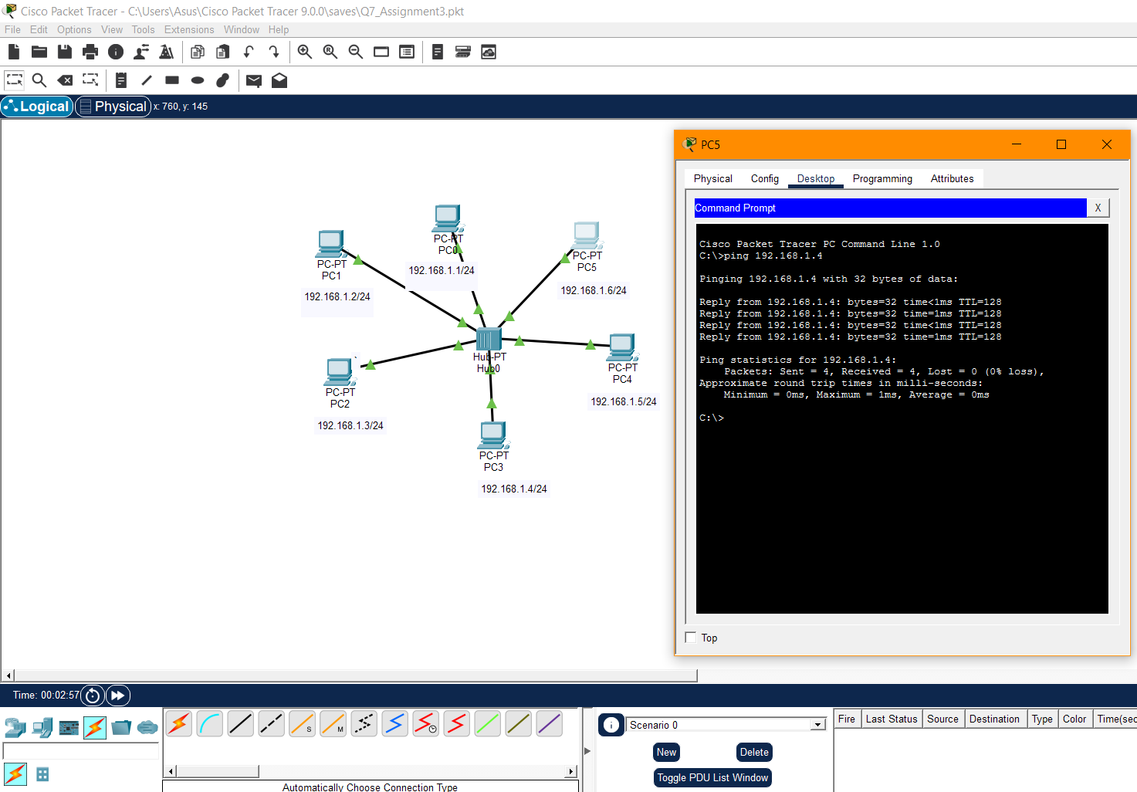

- Create the following ring topology

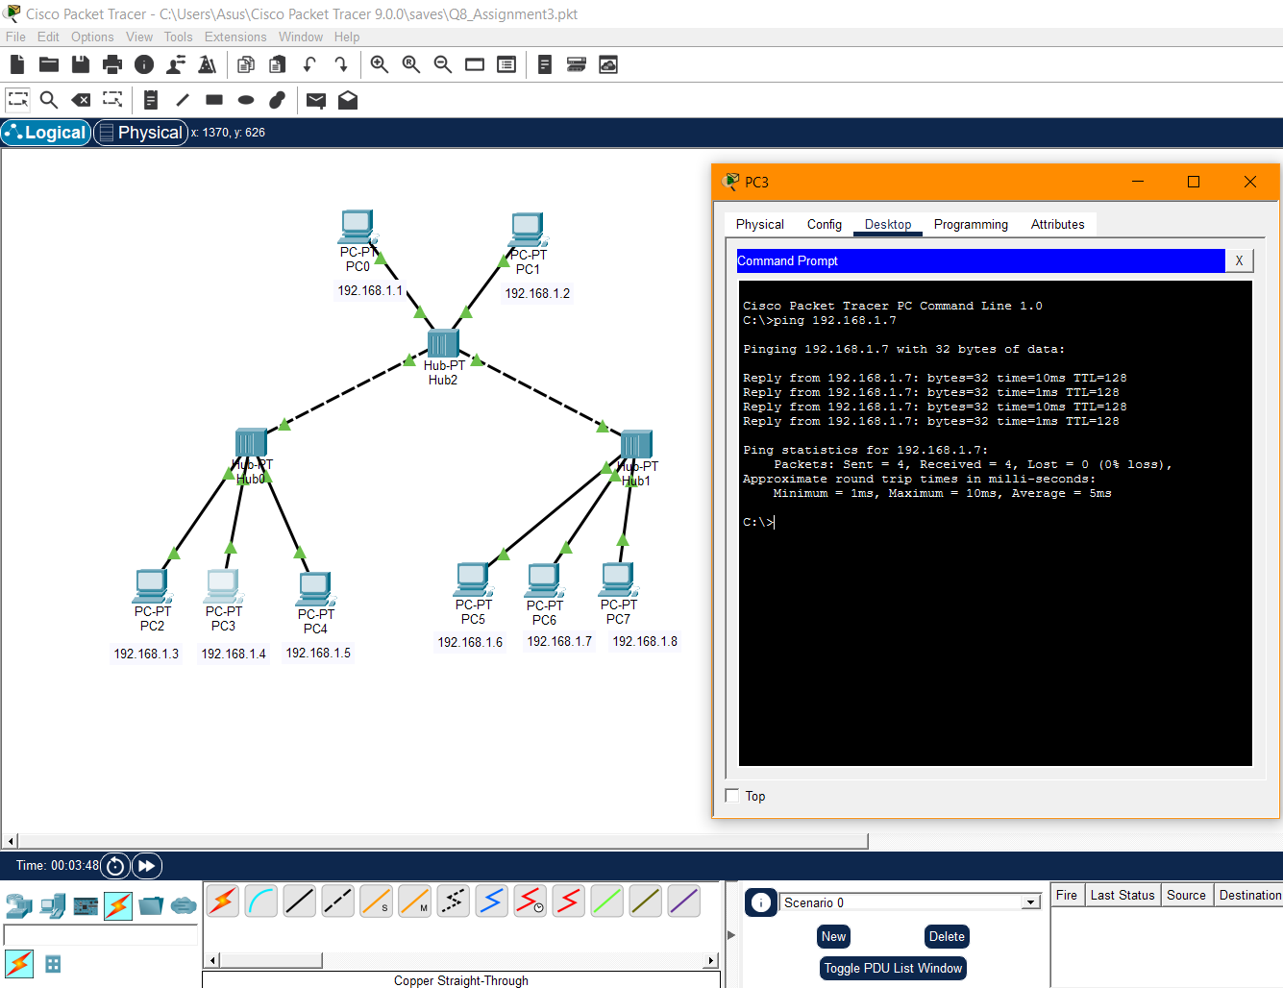

4. To capture and analyze DNS query and response packets
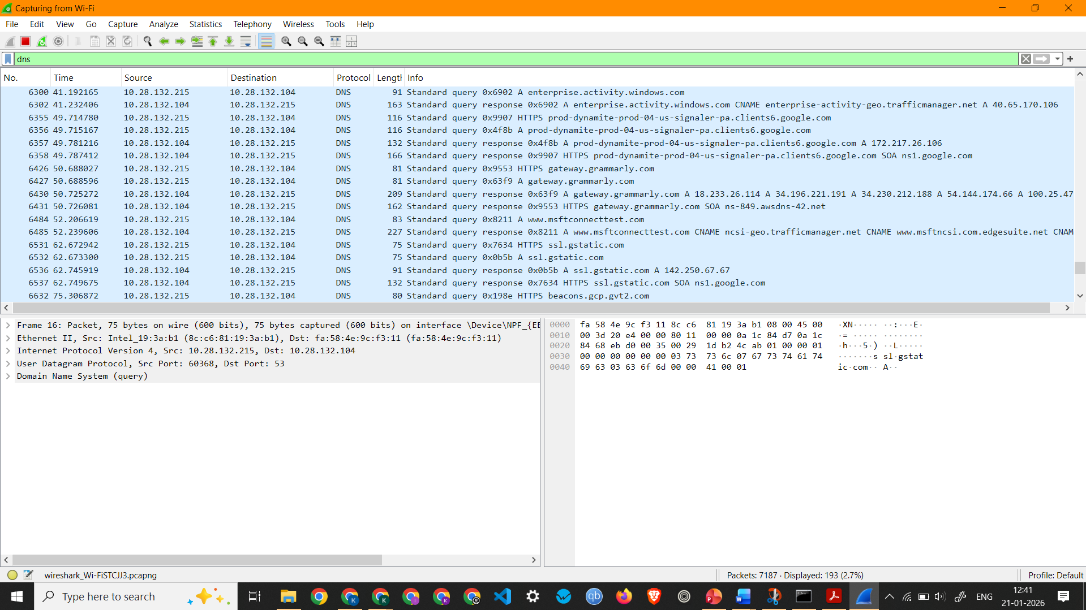
Screenshot showing DNS Packets Capture
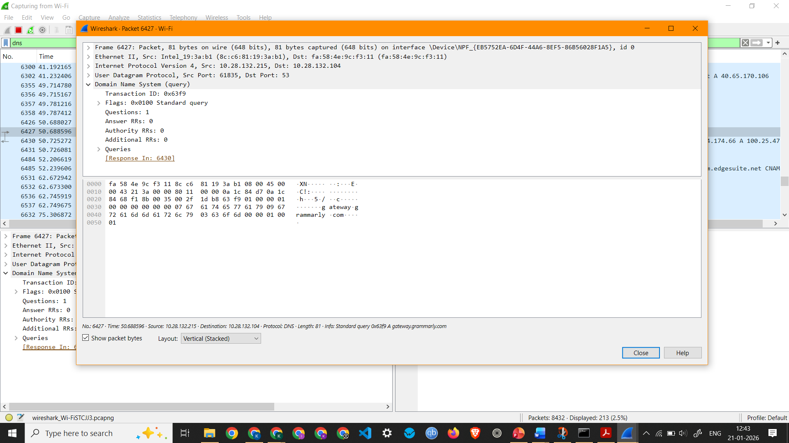
Screenshot showing details of a DNS Packet 6427 (Standard query request)

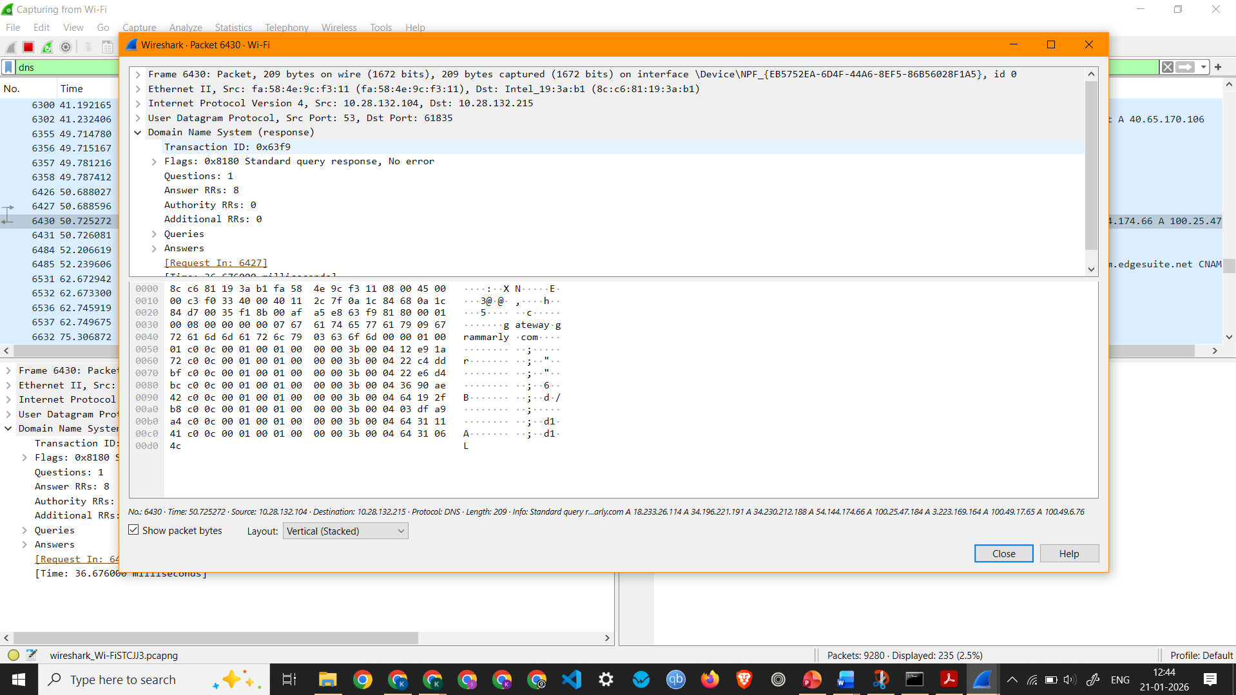
Screenshot showing details of a DNS Packet 6430 (Standard query response)

Observation: DNS Packet 6427 –
  - Interface Used: Wi-Fi
  - Protocols Observed: Ethernet II, Internet Protocol Version 4, and User Datagram Protocol
  - Source IP Address: 10.28.132.215
  - Destination IP Address: 10.28.132.104
  - Packet Length: 81 Bytes
  - Queries - gateway.grammarly.com: type A, class IN

Observation: DNS Packet 6430 –
  - Interface Used: Wi-Fi
  - Protocols Observed: Ethernet II, Internet Protocol Version 4, and User Datagram Protocol
  - Source IP Address: 10.28.132.104
  - Destination IP Address: 10.28.132.215
  - Packet Length: 209 Bytes

5. To capture and analyze HTTP packets
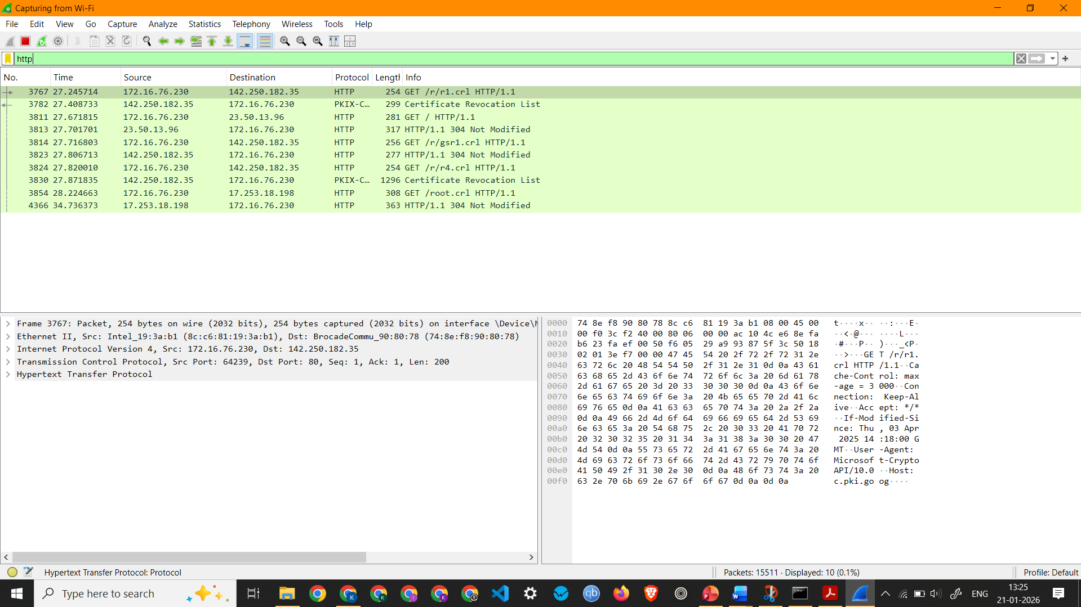
Screenshot showing HTTP Packets Capture
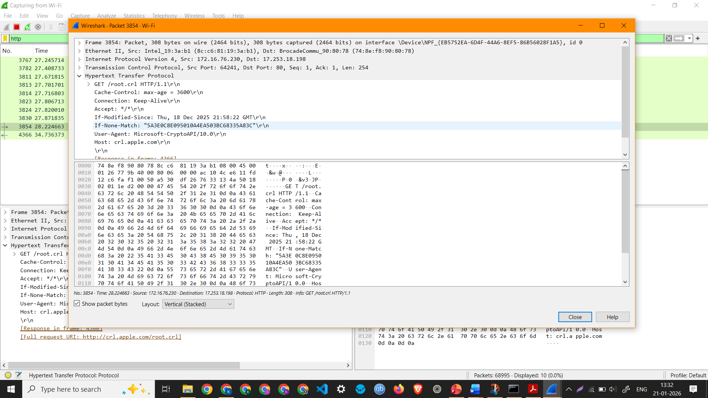
Screenshot showing details of a HTTP Packet (HTTP Request)
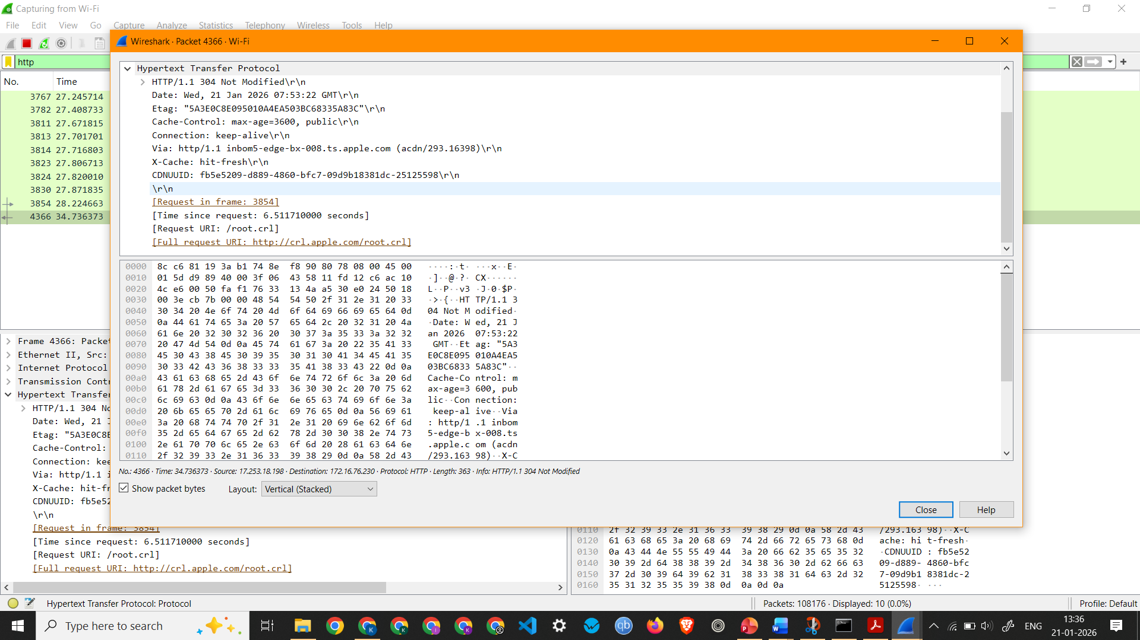
Screenshot showing details of a HTTP Packet (HTTP Response)

Observation: HTTP Request 3854 –
  - Interface Used: Wi-Fi
  - Protocols Observed: Ethernet II, Internet Protocol Version 4, Transmission Control Protocol, Hypertext Transfer Protocol
  - Source IP Address: 172.16.76.230
  - Destination IP Address: 17.253.18.198
  - Packet Length: 308 Bytes
Observation: HTTP Response 4366 –
  - Interface Used: Wi-Fi
  - Protocols Observed: Ethernet II, Internet Protocol Version 4, Transmission Control Protocol, Hypertext Transfer Protocol
  - Source IP Address: 17.253.18.198
  - Destination IP Address: 172.16.76.230
  - Packet Length: 363 Bytes

3. To capture and analyze UDP packets
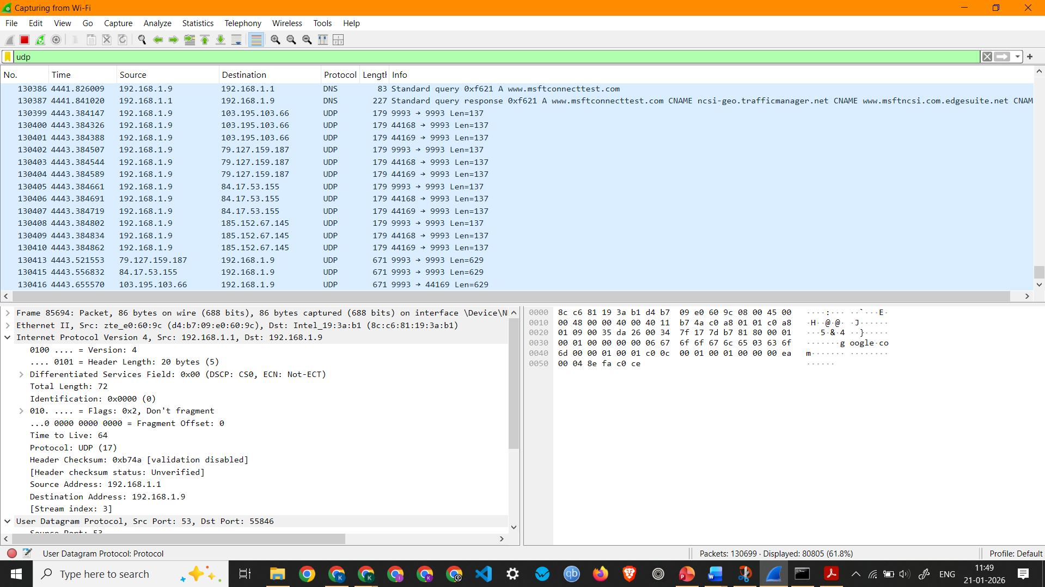
Screenshot showing UDP Packets Capture
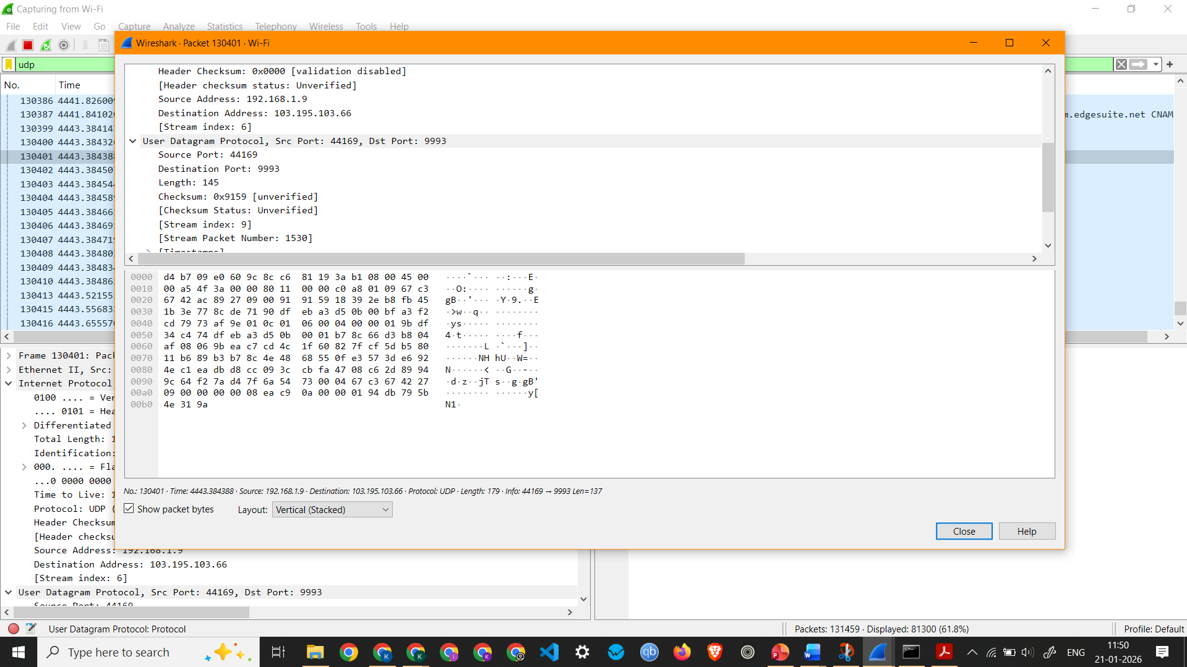
Screenshot showing details of a UDP Packet

Observation: UDP Packet 130401 –
  - Interface Used: Wi-Fi
  - Protocols Observed: Ethernet II, Internet Protocol Version 4, and User Datagram Protocol
  - Source IP Address: 192.168.1.9
  - Destination IP Address: 103.195.103.66
  - Packet Length: 179 Bytes

3. To capture and analyze UDP packets

Screenshot showing UDP Packets Capture

Screenshot showing details of a UDP Packet

Observation: UDP Packet 130401 –
  - Interface Used: Wi-Fi
  - Protocols Observed: Ethernet II, Internet Protocol Version 4, and User Datagram Protocol
  - Source IP Address: 192.168.1.9
  - Destination IP Address: 103.195.103.66
  - Packet Length: 179 Bytes
3. To capture and analyze UDP packets

Screenshot showing UDP Packets Capture

Screenshot showing details of a UDP Packet

Observation: UDP Packet 130401 –
  - Interface Used: Wi-Fi
  - Protocols Observed: Ethernet II, Internet Protocol Version 4, and User Datagram Protocol
  - Source IP Address: 192.168.1.9
  - Destination IP Address: 103.195.103.66
  - Packet Length: 179 Bytes

3. To capture and analyze UDP packets

Screenshot showing UDP Packets Capture

Screenshot showing details of a UDP Packet

Observation: UDP Packet 130401 –
  - Interface Used: Wi-Fi
  - Protocols Observed: Ethernet II, Internet Protocol Version 4, and User Datagram Protocol
  - Source IP Address: 192.168.1.9
  - Destination IP Address: 103.195.103.66
  - Packet Length: 179 Bytes

